Asimov, Six Novel Omnibus R. R. Donnelley & Sons, Octopus, Peerage Press 1986, No dust jacket. Leather bound gray boards with black spine and maroon title plate with gold lettering, gilt edged pages and decorative inner covers. As new hard cover with 864 pages tightly bound and no marks of any kind.
Six novels in one book: Foundation, Foundation and Empire, Second Foundation, The Stars, Like Dust, The Naked Sun and I, Robot. ISBN-10 1555800149

ID 000187 Price $35.00 box 2

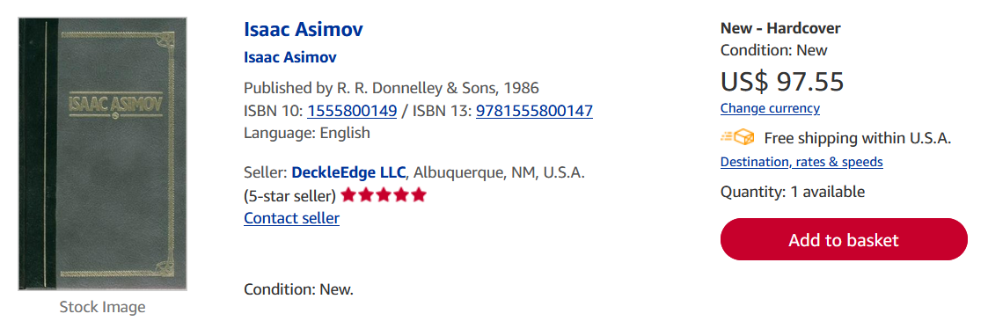
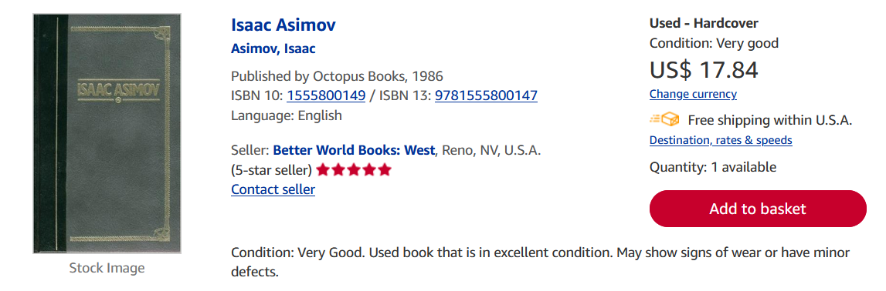
Ebay $32.99

